**MULTI-OBJECT TRACKING ON LOW-EMBEDDED PLATFORM**

**Submitted**

**By**

**D.Anil kumar–BU21EECE0100109**

**Badhrinath reddy–BU21EECE0100435 Rathnakar reddy–BU21EECE0100402**

**Under the Guidance of**

**Mr.B Venkata Kranthi**



**Department of Electrical,Electronics and Communication Engineering**

**GITAM School of Technology**

**GITAM**

**(DEEMED TO BE UNIVERSITY)**

**(Estd. u/s 3 of the UGC act 1956)**

**NH 207, Nagadenehalli, Doddaballapur taluk, Bengaluru-561203 Karnataka, INDIA.**

**DECLARATION**

**I/We declare that the project work contained in this report is original and it has been done by me under the guidance of my project guide.**

**Name:**

**Date: Signature of the Student**

**Department of Electrical,Electronics and Communication Engineering**

**GITAM School of Technology, Bengaluru-561203**



**CERTIFICATE**

**This is to certify that (D.Anil kumar,Badhrinath reddy,Rathnakar reddy) bearing (BU21EECE0100109,BU21EECE0100402,BU21EECE0100435:) has satisfactorily completed Mini Project Entitled in partial fulfillment of the requirements as prescribed by University for VIIth semester, Bachelor of Technology in “Electrical, Electronics and Communication Engineering” and submitted this report during the academic year 2021-2025.**

**[Signature of the Guide] [Signature of HOD**

**Table of contents**

**Chapter 1: Introduction 1**

1.1 Overview of the problem statement 1

1.2 Objectives and goals 1

**Chapter 2 : Literature Review 2**

**Chapter 3 : Strategic Analysis and Problem Definition 3**

3.1 SWOT Analysis 3

3.2 Project Plan - GANTT Chart 3

3.3 Refinement of problem statement 3

**Chapter 4 : Methodology 4**

4.1 Description of the approach 4

4.2 Tools and techniques utilized 4

4.3 Design considerations 4

**Chapter 5 : Implementation 5**

5.1 Description of how the project was executed 5

5.2 Challenges faced and solutions implemented 5

**Chapter 6: Results 6**

6.1 outcomes 6

6.2 Interpretation of results 6

6.3 Comparison with existing literature or technologies 6

**Chapter 7: Conclusion 7**

**Chapter 8: Future Work 8**

Here write Suggestions for further research or development Potential improvements or extensions 8

**References 9**

Chapter 1: Introduction

1.1 Overview of the problem statement

Design and implement an MOT system for an autonomous vehicle using Raspberry Pi. The system shall be able to determine with accuracy the location of multiple objects in real time, such as pedestrians, vehicles, or other obstacles, to guarantee safety and informed decision-making when navigating any setting that concerns dynamic environments of driving.

1.2 Objectives and goals

Multi-object tracking (MOT) is vital in computer vision for detecting and identifying multiple objects in videos. While pedestrian tracking has advanced, tracking vehicles in complex traffic scenarios remains challenging due to higher speeds, nonlinear motion, and cluttered backgrounds. Vehicles' faster, complex motion and traffic scenes' frequent occlusions and background changes complicate detection and tracking. Existing methods often struggle with nonlinear vehicle motion and low-confidence detections in these environments

# Chapter 2 : Literature Review

Discuss foundational tracking algorithms such as the Kalman filter, Particle filter, and their extensions to multi-object scenarios.

Review modern deep learning-based MOT approaches, including detection-based tracking methods like SORT (Simple Online and Realtime Tracking) and DeepSORT.

Examine the characteristics and constraints of low-power embedded platforms such as microcontrollers, Raspberry Pi, NVIDIA Jetson, and FPGAs.

Discuss the trade-offs between computational efficiency and tracking accuracy on these platforms.

Review lightweight object detection models suitable for embedded platforms, such as opencv,YOLO, and EfficientDet.

Analyze how these models are optimized for power and memory efficiency while still providing accurate detections for MOT tasks.

# Chapter 3 : Strategic Analysis and Problem Definition

## 3.1 SWOT Analysis

STRENGTHS:

S1.importance in Autonomous Driving

S2. Advancements in Pedestrian Tracking

S3. Focus on Complex Environments

WEAKNESS:

W1. Challanges with non linear motion

W2. Low-Confidence Detections W3.Limited Generalizability

OPPORTUNITIES:

O1. improvement of Algorithms

02. Incorporation of New Techniques

O3.Growing need for Automonous vehicles

THREATS:

T1. Rapid Technological Changes

T2. Competition from Emerging Technologies

### 3.2 Project Plan - GANTT Chart

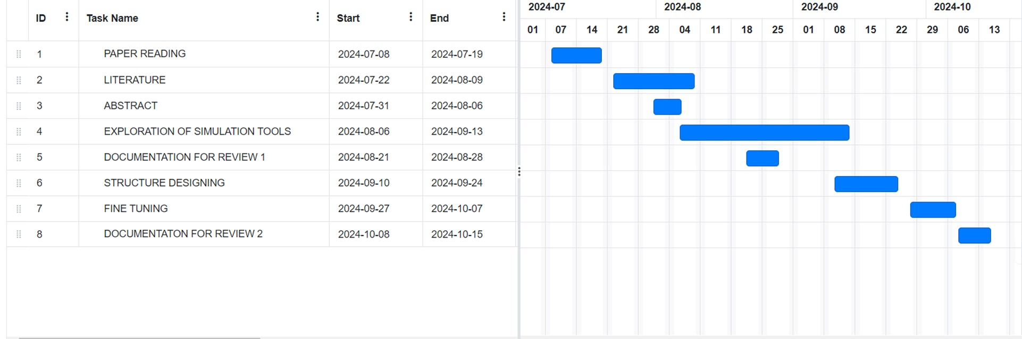

##### 3.3 Refinement of problem statement

This can be demanding for the system considering that Raspberry Pi has resource constraints. It needs to balance the detection accuracy of the system and its reliability in tracking with the performance in real time. With these factors in mind, the system will be tasked with identifying and tracking dynamic objects in challenging driving conditions as it effectively deals with occlusions, identity switches, and variability in the movement of the objects.

The project specifically integrates YOLO for detection purposes and DeepSORT for tracking, which highlights the problem with resource-constrained Raspberry Pi. Technical objectives include optimization towards real-time performance, challenging environments, and seamless integration into autonomous vehicle systems.

# Chapter 4 : Methodology

# 4.1 Description of the approach

1.Data collection

2.Detection

3.Tracking

4.Data association

4.2 Tools and techniques utilized

Hardware tools:Rasberrypi

Software tools:Yolo for detection and Deepsort for tracking

4.3 Design considerations:

Algorithm selection and optimization

Hardware

Real time performances

Latency and communication

Handling dynamic and complex environments

Robustness and accuracy

Model scalability and flexibility Evaluating and testing

Chapter 5 : Implementation

5.1 Description of how the project was executed

Literature survey

Algorithm selection

Embedded platform selection and implementation

System integration and testing

Prototype

Evaluation and testing

Conclusion

5.2 Challenges faced and solutions implemented

Faced challenges on implementing the deepsort algorithm.In deepsort algorithm while executing, code getting implemented but not reflecting in output

Chapter 6:Results

6.1 outcomes

Real-time tracking performance

Tracking accuracy

Memory testing

Prototype

### 6.2 Interpretation of results

YOLO for detection:

Detection accuracy

True positive

False positive

Deepsort for tracking:

Track consistency

ID switches

Occulsion handling

#### 6.3 Comparison with existing literature or technologies

Chapter 7: Conclusion

This project successfully implemented a real-time Multiple Object Tracking (MOT) system using YOLO for object detection and DeepSORT for tracking on a Raspberry Pi. The combination of these technologies demonstrated the capability to detect and track multiple objects with reasonable accuracy and consistency, even on a resource-constrained device.

However, the performance was limited by the Raspberry Pi’s processing power, which led to lower frame rates and occasional tracking issues, such as ID switching and difficulty handling object occlusions. While YOLO's detection was generally robust, trade-offs in speed and accuracy were observed, particularly when using lightweight versions like YOLOv4-tiny.

# Chapter 8 : Future Work

The project's subsequent stages will then concentrate more on the Raspberry Pi's deeper hardware integration and improvements. To continue the software work where we are stuck and increase the effectiveness of object identification and tracking, future research would look into hardware like the Rasberypi.

# References